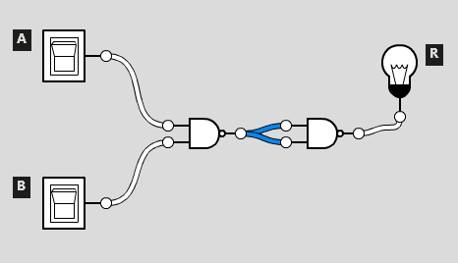

This is how to build an AND gate, using only NAND gates.

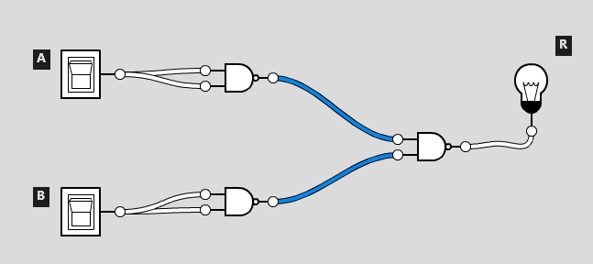

This is how to build an OR gate, using NAND gates

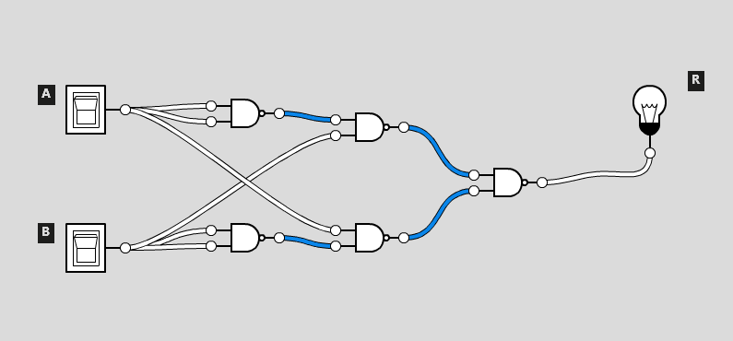How to build an XOR gate from NAND gates

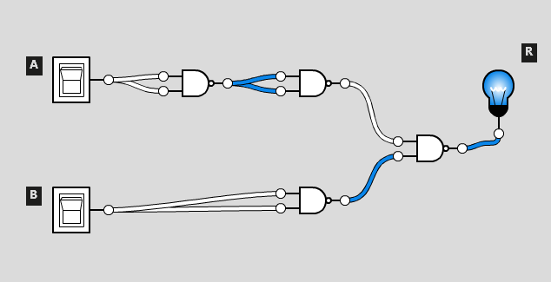

How to build an IMPLIES gate, using only NAND gates